EXPERIMENT 5
BUILDING REPORTS, DASHBOARDS, AND CUSTOM PAGES (UI BUILDER) IN ZOHO CREATOR
Gym Membership Enrollment & Front Desk Management

Parikshith P
Reg. No: 2116241401062
Computer Science and Business Systems
Rajalakshmi Engineering College, Chennai

1. Aim
To create and customize reports, explore graphical components, and design a custom dashboard page using the UI Builder in Zoho Creator for the Gym Membership Enrollment and Front Desk Management application.

2. Software Requirements
- Zoho Creator low-code development platform
- Web browser
- Internet connection
- Gym Membership Enrollment and Front Desk Management application

3. Introduction
Zoho Creator is a low-code application development platform that enables users to create business applications using visual development tools. It provides features for designing forms, generating reports, creating dashboards, and building custom pages without requiring extensive traditional programming.
Reports are used to display, organize, and analyze records collected through application forms. They allow users to view information in a structured format and access important details conveniently. For example, a gym management application can use reports to display member names, ages, membership types, residential addresses, phone numbers, and email addresses.
Dashboards provide a consolidated view of important business information. They can combine charts, summary panels, and reports on a single page, helping users understand information more efficiently. Graphical components such as pie charts and bar charts make it easier to compare categories and identify patterns in stored data.
The UI Builder in Zoho Creator provides a visual interface for arranging these components. Users can add elements to a page, organize their layout, and configure the components according to the requirements of the application.
In this experiment, the existing Gym Membership Enrollment and Front Desk Management application was used to explore report presentation and custom dashboard creation.

4. Procedure

Step 1: Opening the Existing Application
The Gym Membership Enrollment and Front Desk Management application was opened in Zoho Creator. The application contained a membership enrollment form and a corresponding report. The form was used to collect member information, while the report displayed the submitted records.

Step 2: Viewing the Membership Enrollment Report
The Membership_Enrollment_Form Report was opened from the application's navigation panel. The report displayed three sample membership records.
The visible fields included member name, age, membership type, residential address, phone number, and email address. The report presented the information in a tabular format, allowing the records to be viewed and compared conveniently.
Reports are useful in business applications because they provide a structured view of collected information. They also serve as a foundation for creating dashboards and analyzing application data.
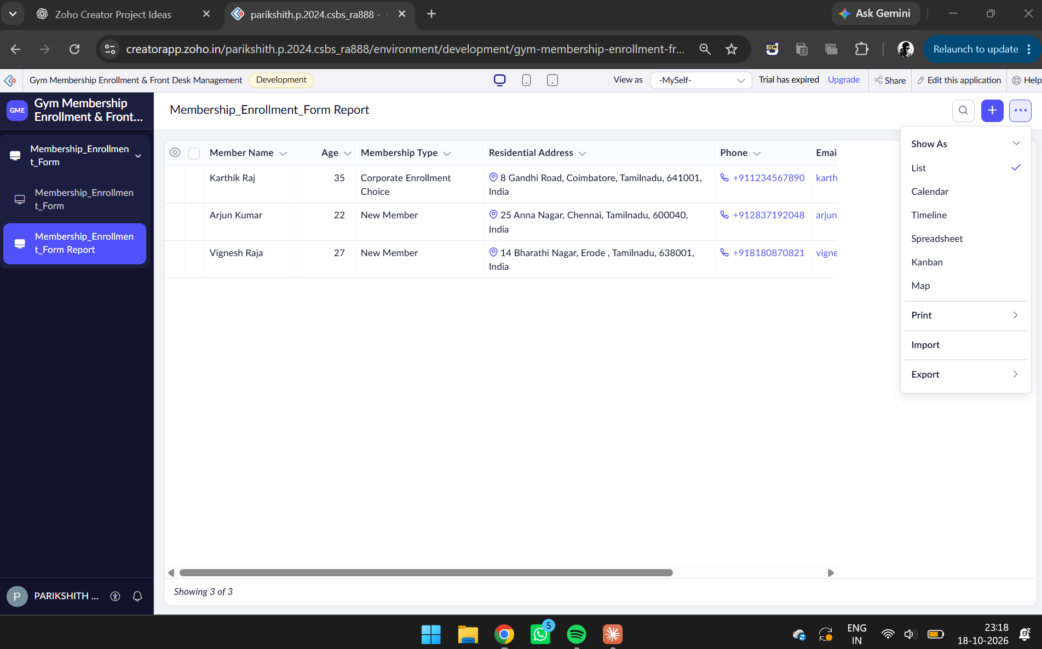
Figure 1. Membership_Enrollment_Form Report displaying three member records.
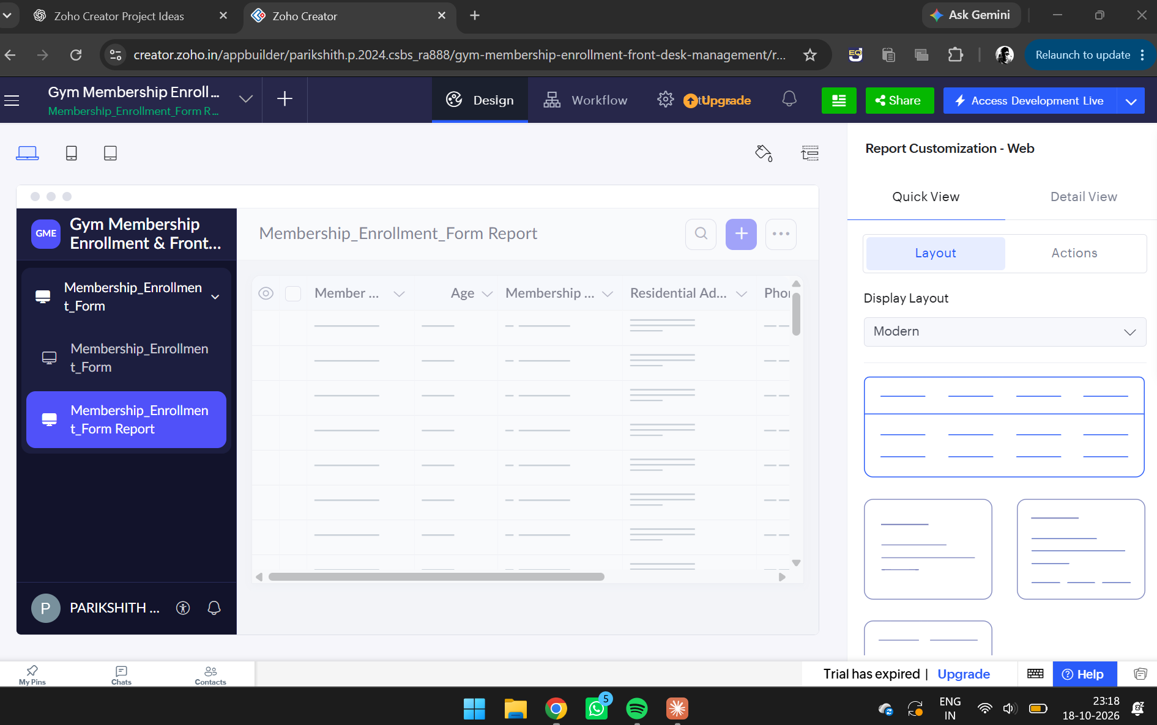
Figure 2. Report Customization panel for the Membership_Enrollment_Form Report, showing the available display layout options.

Step 3: Creating a Custom Dashboard Page
A new custom page named Membership_Dashboard was created using the Page Builder in Zoho Creator. The custom page was intended to provide a consolidated interface for presenting gym membership information.
The Page Builder contained several elements that could be added to the page, including Panel, Board, Chart, Gauge, Search, Form, Report, Snippets, and Button. These components allow users to construct interactive and informative application pages using a visual design approach.
The blank page provided a workspace where different components could be arranged to form a dashboard layout.
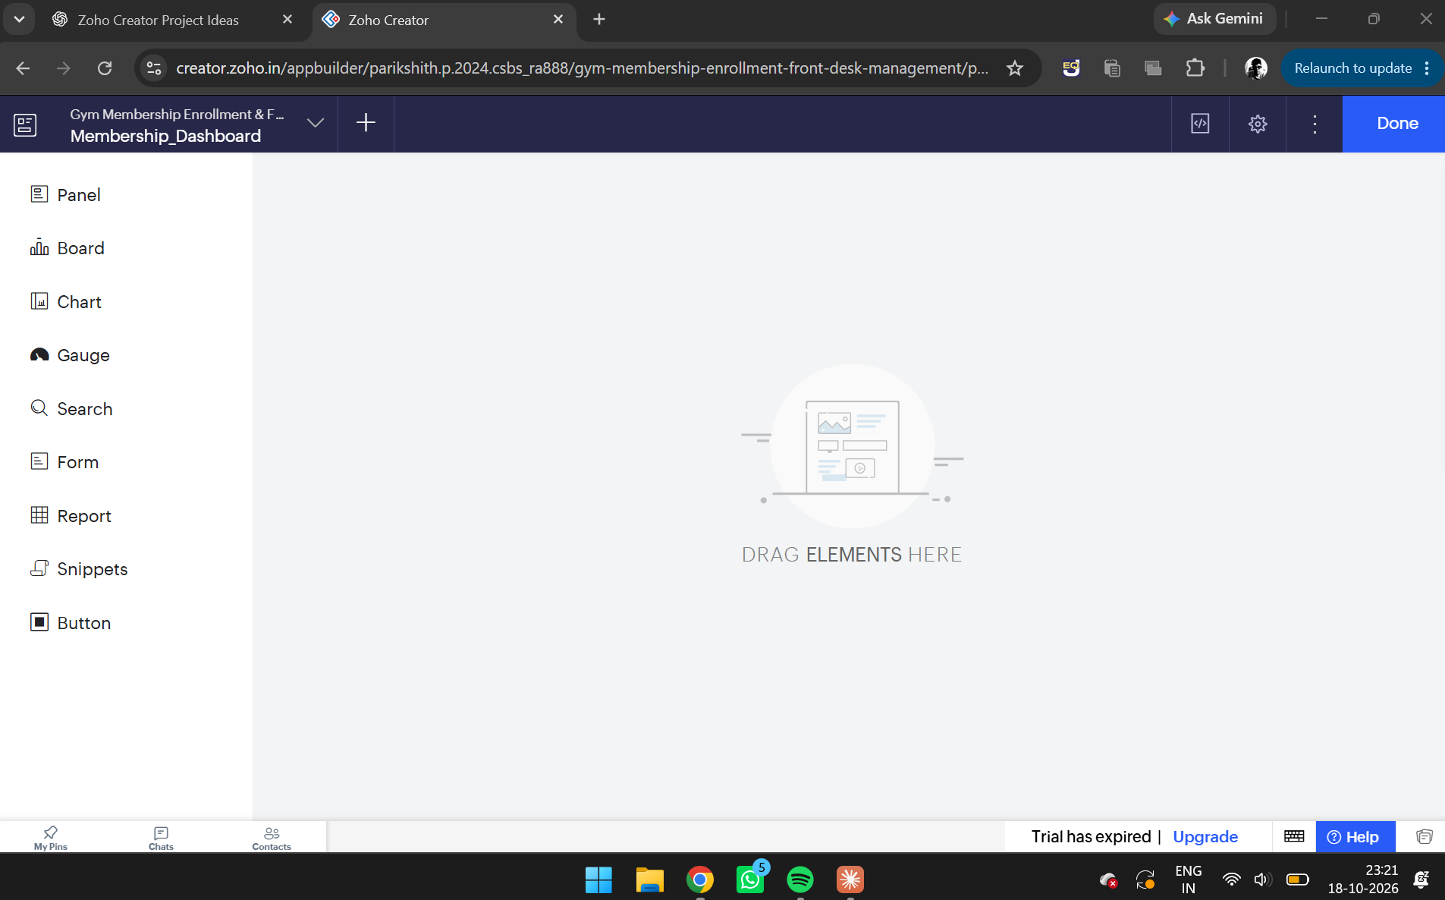
Figure 3. Membership_Dashboard opened in the Zoho Creator Page Builder.

Step 4: Exploring the Panel Component
The Panel component was explored to understand how summary information can be presented in a dashboard. Panels can be used to highlight important information, such as total memberships, new enrollments, or other key indicators, when connected to appropriate data.
A panel-based layout can help organize dashboard content into distinct sections. This improves readability and allows users to identify important information quickly.
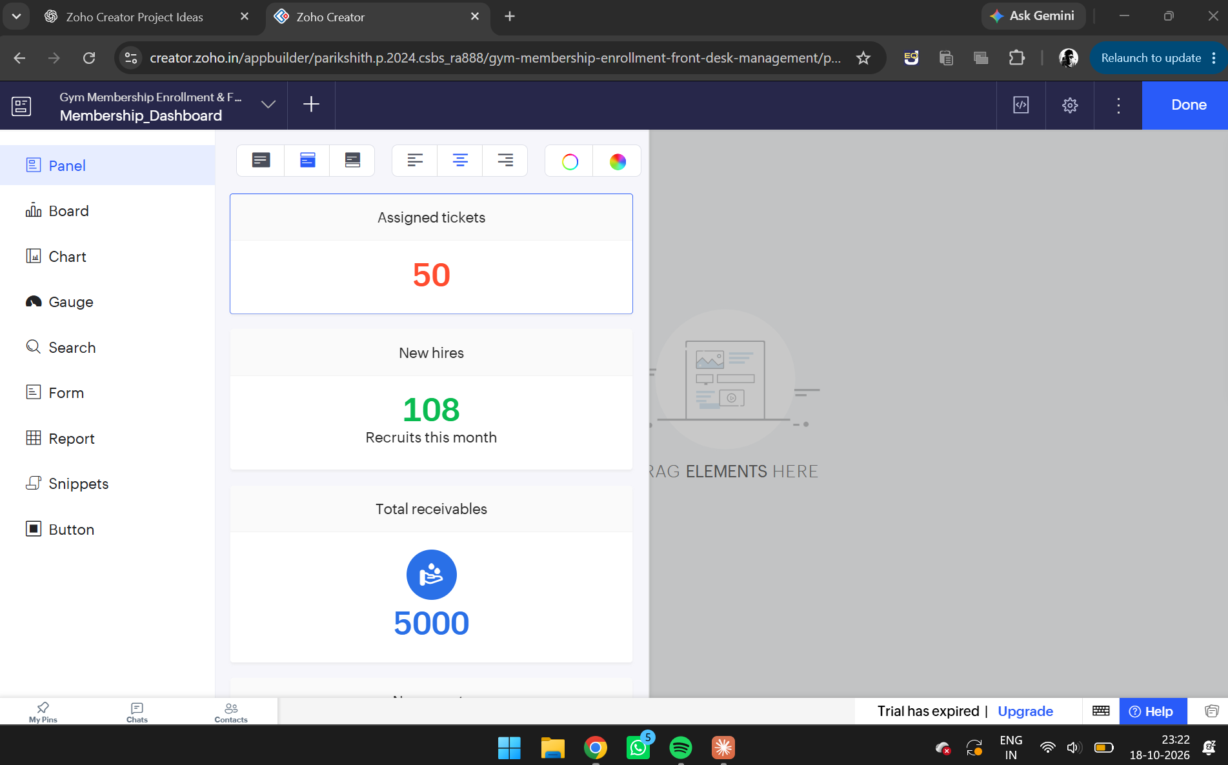
Figure 4. Panel component explored in the Page Builder, showing summary indicator tiles.

Step 5: Adding a Pie Chart Component
The Chart component was explored, and a pie chart was added to the dashboard page. A pie chart is useful for representing the distribution of records among different categories.
In the gym membership application, a pie chart can be configured to display the number of members belonging to different membership types. Each segment represents a category, and the relative size of the segment indicates its proportion of the total.
This type of visualization can help gym administrators understand how membership records are distributed across available categories.

Step 6: Adding a Bar Chart Component
A bar chart component was added to the custom dashboard page. Bar charts represent values using rectangular bars and are useful for comparing multiple categories.
In the membership application, a bar chart can be configured to compare the number of members in different membership categories or plans. It provides a visual alternative to reading individual records from a table.
The chart requires an appropriate data source and grouping configuration to display meaningful membership statistics.

Step 7: Adding the Membership Report
A report component was added to the dashboard page to provide access to the membership records alongside the graphical components.
The existing Membership_Enrollment_Form Report contained member details such as name, age, membership type, address, and contact information. Displaying the report on the dashboard can help users view individual records while referring to the graphical summaries.
Combining reports and charts provides both detailed information and a summarized view of the application's data.
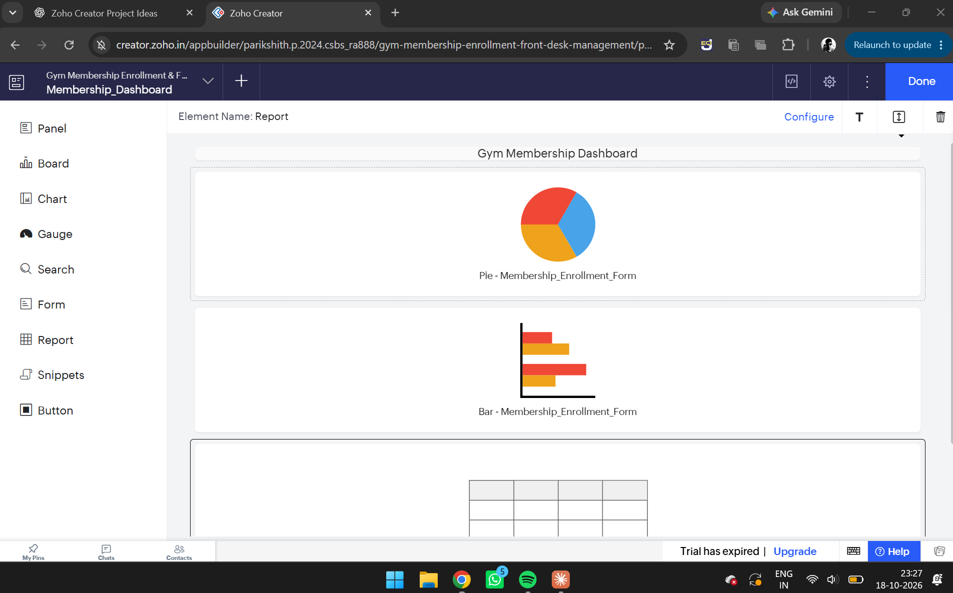
Figure 5. Membership_Dashboard Page Builder showing the pie chart, bar chart, and report components.

Step 8: Arranging and Reviewing the Dashboard
The dashboard components were arranged within the Page Builder to demonstrate how multiple elements can be presented on a single page. The heading, charts, and report were organized to provide a structured interface for viewing membership information.
The layout was reviewed to understand how the different components contribute to the overall presentation of data. A well-organized dashboard should make important information easy to locate and understand.
The page was prepared for saving and previewing, subject to the features available in the current Zoho Creator environment.

5. Description of Components

5.1 Reports
Reports display records submitted through application forms. They help users view and organize stored information in a tabular or other supported format. In this experiment, the membership report displayed the details of three sample members.

5.2 Panels
Panels are visual elements that can highlight important information or divide a page into organized sections. When configured with suitable data, they can be used to present summary indicators.

5.3 Pie Charts
Pie charts display the distribution of data across categories. They are suitable for representing membership composition when the underlying data has been correctly configured.

5.4 Bar Charts
Bar charts compare values across different categories. They can help administrators compare membership counts and identify differences between categories.

5.5 Custom Pages
Custom pages allow multiple UI components to be arranged within a single interface. They provide flexibility in presenting information according to the requirements of a business application.

6. Advantages
- Improved data presentation: Reports organize membership records in a structured format.
- Visual analysis: Charts make comparisons between categories easier to understand.
- Centralized information: A dashboard can bring reports and graphical elements together on one page.
- Reduced development effort: The visual Page Builder reduces the need to create the entire interface through traditional programming.
- Flexible layout: Different components can be arranged according to application requirements.
- Better decision support: Properly configured dashboards can help administrators understand membership trends and make informed decisions.

7. Result
The Membership_Enrollment_Form Report was viewed, and a custom page named Membership_Dashboard was created using the Zoho Creator Page Builder. The Panel, Chart, and Report components were explored, and pie chart, bar chart, and report elements were added to demonstrate the design of a consolidated dashboard for gym membership management.

